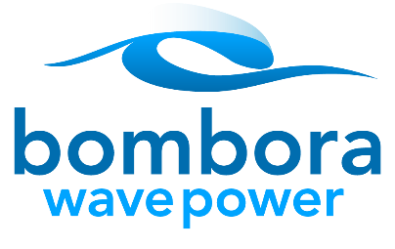
ARENA support for Bombora Wave

Energy Business News
15th January 2016

Press Media

January 15, 2016 11:31 am Category: Latest News, Wind A+ / A-
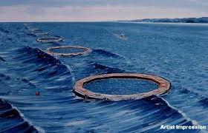
Artists impression of a Bombora array
Wave developer Bombora’s pilot project in Western Australia is set to receive financial support from the Australian Renewable Energy Agency (ARENA) for a detailed cost of energy study for its Wave Energy Convertor (WEC).
ARENA said this week it would contribute as much as $181,000 towards the completion of the assessment.
Bombora Wave launched its mid-scale field trial on Melville Waters off the Western Australian coast last September after five years of development.
“This study is an opportunity for Bombora to prove the case for its technology and continue the journey towards a commercial solution that could strengthen Australia’s position as a leader in wave power,” ARENA CEO, Ivor Frischknecht, said.
The WEC comprises a responsive rolling membrane installed on a long concrete arm resting on the seafloor, which pressurises air and passes it through a turbine to generate electricity.
The study will build on previous investigations line design reviews and production costing by contacting key suppliers of all major components of the system. Results are due in March this year.

